- Retrieve the total number of orders placed.

- select count(order_id)as total_order from orders

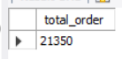

- Calculate the total revenue generated from pizza sales.

- select round(sum(order_details.quantity * pizzas.price),2) as total_sales from
order_details join pizzas on pizzas.pizza_id = order_details.pizza_id;

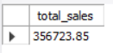

- Identify the highest-priced pizza.

- select pizzas.price, pizza_types. pizza_type_id
from pizzas join pizza_types on pizzas.pizza_type_id = pizza_types.pizza_type_id
order by pizzas.price desc limit 1



4) Identify the most common pizza size ordered.
- select pizzas.size, count(order_details.order_details_id) as Order_count from pizzas join order_details on pizzas. pizza_id = order_details.pizza_id group by pizzas.size order by order_count desc;

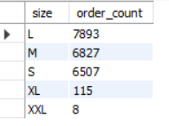

5) List the top 5 most ordered pizza types along with their quantities.
Ans:-
select pizza_types.name,
sum(order_details.quantity) as quntity
from pizza_types join pizzas
on pizza_types.pizza_type_id = pizzas.pizza_type_id
join order_details
on order_details.pizza_id = pizzas.pizza_id
group by pizza_types.name order by quntity desc limit 5;

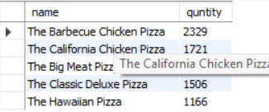
Intermediate:
- Join the necessary tables to find the total quantity of each pizza category ordered.

Ans:-

SELECT pt.category, SUM(od.quantity) AS total_quantity
FROM order_details od
JOIN pizzas p ON od.pizza_id = p.pizza_id
JOIN pizza_types pt ON p.pizza_type_id = pt.pizza_type_id
GROUP BY pt.category
ORDER BY total_quantity DESC;

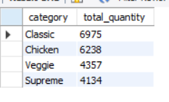

2) Determine the distribution of orders by hour of the day.

Ans:-

SELECT HOUR(order_time) AS order_hour, COUNT(*) AS total_orders
FROM orders
GROUP BY HOUR(order_time)
ORDER BY order_hour;

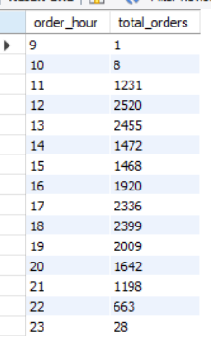

- Join relevant tables to find the category-wise distribution of pizzas.

Ans:-

SELECT pt.category, COUNT(p.pizza_id) AS total_pizzas
FROM pizzas p
JOIN pizza_types pt ON p.pizza_type_id = pt.pizza_type_id
GROUP BY pt.category
ORDER BY total_pizzas DESC;

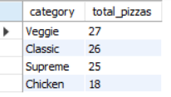

4) Group the orders by date and calculate the average number of pizzas ordered per day.

Ans:-

SELECT AVG(daily_order_count) AS avg_pizzas_per_day
FROM (
SELECT o.order_date, SUM(od.quantity) AS daily_order_count
FROM order_details od
JOIN orders o ON od.order_id = o.order_id
GROUP BY o.order_date
) AS daily_orders;

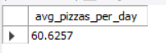

5) Determine the top 3 most ordered pizza types based on revenue.

Ans :-

SELECT pt.name, SUM(od.quantity * p.price) AS total_revenue
FROM order_details od
JOIN pizzas p ON od.pizza_id = p.pizza_id
JOIN pizza_types pt ON p.pizza_type_id = pt.pizza_type_id
GROUP BY pt.name
ORDER BY total_revenue DESC
LIMIT 3;

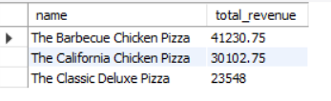

Advanced

1) Calculate the percentage contribution of each pizza type to total revenue.
Ans:-

select pizza_types.category,
round(sum(order_details.quantity*pizzas.price) / (SELECT
ROUND(SUM(order_details.quantity * pizzas.price),
2) AS total_sales
FROM
order_details
JOIN
pizzas ON pizzas.pizza_id = order_details.pizza_id) * 100,2) as revenue
from pizza_types join pizzas
on pizza_types.pizza_type_id = pizzas.pizza_type_id
join order_details
on order_details.pizza_id = pizzas.pizza_id
group by pizza_types.category order by revenue desc;

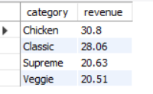

- Determine the top 3 most ordered pizza types based on revenue for each pizza category.

ANS:-

select name, revenue from
(select category , name, revenue,
rank() over (partition by category order by revenue desc) as rn
from
(select pizza_types.category, pizza_types.name,
sum((order_details.quantity) * pizzas.price) as revenue
from pizza_types join pizzas
on pizza_types.pizza_type_id = pizzas.pizza_type_id
join order_details
on order_details.pizza_id = pizzas.pizza_id
group by pizza_types.category, pizza_types.name) as a) as b
where rn <=3;

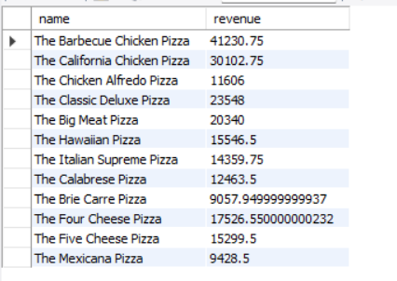

2) Analyze the cumulative revenue generated over time.

ANS:-
SELECT
o.order_date,
SUM(SUM(od.quantity * p.price)) OVER (ORDER BY o.order_date) AS cumulative_revenue
FROM order_details od
JOIN orders o ON od.order_id = o.order_id
JOIN pizzas p ON od.pizza_id = p.pizza_id
GROUP BY o.order_date
ORDER BY o.order_date;

